Minutes of the Japanese Parliamentary Committee of
the National Diet of Japan for World Federation
Exchange of views on

The Role of India and Japan in
Building Global Governance in the New International Society

2024, April 23rd, Tuesday,16:00-17:30
First Member’s Office Building of the House of Representatives
B1, Special Conference Room

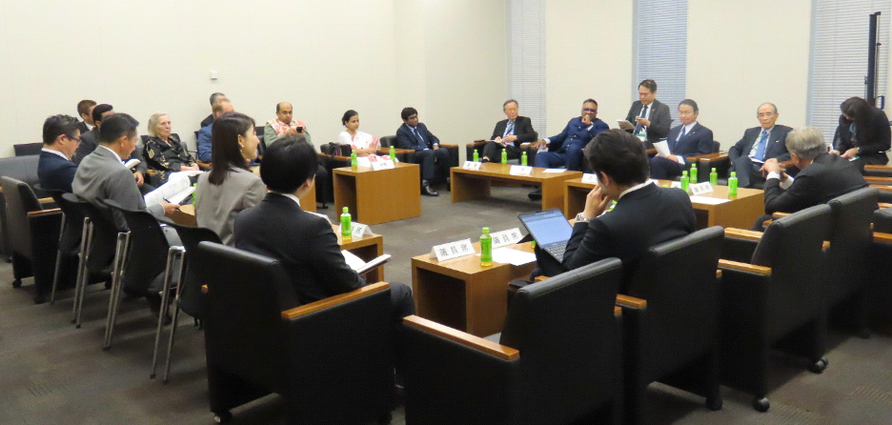
Overall Moderator
Masakuni Tanimoto
Deputy Director, Secretariat of
The Japanese Parliamentary Committee for World Federation
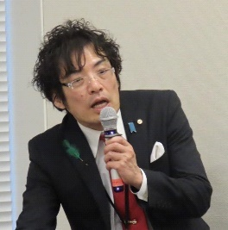

Opening Session One

Mr. Seishiro Eto, Chairman of the Japanese Parliamentary Committee for the World Federation and a member of the House of Representatives and the Liberal Democratic Party of Japan

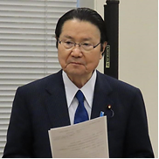
On behalf of the Japanese Parliamentary Committee for the World Federation, I would like to express my sincere gratitude to Mr. Raj Kumar, Vice Chancellor of O.P. Jindal Global University, and many other distinguished guests for joining us today. The Japanese Parliamentary Committee for World Federation was established in 1945, soon after the end of World War II. Since then, we have been striving for lasting peace in the world, and this fiscal year marks its 75th anniversary. India, as the center of the Global South, which has made remarkable economic development in recent years, has an important mission and role to play in building global governance in the new international community. I am very much looking forward to hearing your views on the role of education in India and how Japan and India can collaborate to create a better world. I would like to apply what I heard today to the future activities of the Japanese Parliamentary Committee for the World Federation, and I would like to make further efforts to establish more effective global governance, working hand in hand with India. That concludes my brief remarks.

Mr. Mitsuo Ohashi, Chairman of the World Federalist Movement of Japan
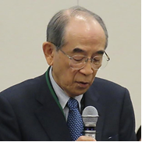
This conference is hosted by the Japanese Parliamentary Committee for World Federation, an organization of Diet members. I am Mitsuo Ohashi, of the private-sector World Federalist Movement, which is a testament to our shared commitment to addressing global issues such as wars, refugees, and global warming through global governance. I firmly believe that India's role in global governance will be pivotal in the future, given its impressive economic development. Today's exchange of views holds great significance as we collectively consider the evolving role of India and Japan in global governance. Together, we can shape a more equitable and sustainable future.

Mr. Masahito Moriyama, Minister of Education, Science, Culture, and Sports, and a member of the Liberal Democratic Party and the House of Representatives of the National Diet of Japan
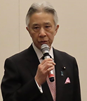
My name is Masahito Moriyama, and I am the Minister of Education, Culture, Sports, Science and Technology. Vice President Raj Kumar and other distinguished guests, thank you for inviting me here today and for the opportunity to present my views.
My task is to promote dialogue and cooperation with India in both education and science and technology. India is one of the most important countries in the Global South, and the Government of Japan is keen to strengthen relations with India. Among these, we recognize the importance of enhancing the relations between the universities of our two countries, and we believe that the exchange of students from Japan to Indian universities and students from India to Japanese universities would strengthen the Japan-India relationship. We also believe that Japan should learn from India, especially since India is advanced in science and technology.
Today is a very good opportunity to discuss the current status of Japan-India relations and how we can develop our relationship in education and other areas. I am very sorry, but I must leave the room now to attend other official duties. However, I would like to hear more from my colleagues later on, and we will consider how and in which areas Japan-India relations should be developed closer together.

Dr. Raj Kumar, Vice Chancellor of the O.P. Jindal Global University
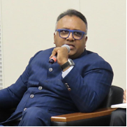
I thank you for inviting me here today. I am honored to be able to meet and speak with such distinguished members of the Diet who are involved in policy-making in Japan. I would like to thank once again all the distinguished people gathered here today, including Chairman Seishiro Eto, Chairman Mitsuo Ohashi, Mr. Kiyoshi Odawara, and Mr. Sukehiro Hasegawa, for taking time out of their busy schedules to meet with us and to engage in dialogue. I am a professor of law and also the Vice Chancellor, or President, of O.P. Jindal Global University.
I received law degrees from the University of Delhi, Oxford University, Harvard University, and the University of Hong Kong. I later returned to India to organize the O.P. Jindal Global University, where I was the founding Vice Chancellor and Vice President. First of all, I would like to say that the relationship between India and Japan is historically very important for us.
I would like to share five basic ideas and historically significant events that have greatly influenced the relationship between Japan and India. first, both countries have a long historical tradition, like an umbilical cord. For example, both countries are built on Buddhist religious practices, ideas, and philosophies, which have deeply influenced and permeated the people of both countries and formed the bonds between people. The second was that soon after the end of World War II, in the early 1950s, India did not participate in the San Francisco Conference and enacted an agreement recognizing Japan's independence and autonomy. The third is the relationship between the two countries in civilization. As you may know, the Japanese Suzuki Motor Company established the relationship between India and Japan, which led to the development of the Indian automobile industry and the democratization of access to transportation. This made it possible for the Indian middle class to own a car. For example, my parents eventually owned two Suzuki cars. My children can travel by car with this Suzuki contribution. We came to know Japan through Suzuki cars. The fourth point in Japan-India relations is the rule of law and democratic values we share. While there are countries in the Asia-Pacific region that do not take the rule of law and democratic approach, we must cooperate with them as countries that share the same values. The fifth point is India's population structure. India's population is 1.5 billion, of which 1 billion are young people under the age of 30. Young Indians are eager to build relationships with young Japanese. As India grows into a larger economy, it will become increasingly important for both countries, universities, and young people to cooperate. From the global governance perspective, Indian Prime Minister Modi has also advocated the Indo-Pacific Alliance, in which Japan is the most important partner in the Asia-Pacific region. Japan and India are within the same framework of the Indo-Pacific region, and both countries should take active leadership in pursuit of stability and peace in the Asia-Pacific region, including the South China Sea. Finally, with regard to complex issues that need to be addressed, such as climate change, India recognizes the importance of cooperation and the complexity of the issues and accepts the need to proactively achieve the SDGs. In achieving the SDGs, India needs closer relations and cooperation with Japan, so that both countries can contribute to peace, stability, and sustainability in the Indo-Pacific region and the world. Thank you for your kind attention.

Session Two
Statements and Remarks by
Members of Political Parties and the National Diet of Japan

Japan Innovation Party, Mr. Yoshiharu Asakawa, A member of the House of Representatives
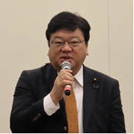
In my two years on the Security Committee, I am acutely aware that the relationship between India and Japan is the most important in history. I hope to make it thicker on all fronts so that we can continue to maintain peace in the future.

Liberal Democratic Party, Mr. Kiyoshi Odawara, Former Vice Minister of Foreign Affairs and member of the House of Representatives
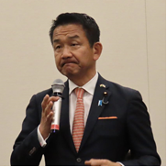
This month, the Indian Ambassador to Japan, H.E. Sibi George, was in Tachikawa, my constituency, for the Tachikawa Greening Festival, an event on SDGs and environmental issues. The reason why it came about is because I had heard Foreign Minister H.E. Jaishankar's speech two months earlier. I also had the opportunity to read his first book, The India Way, and his second book, Why Bharat Matters. What these told me was the reason why India joined the Quad. They also explain why India is buying Russian weapons.
One thing you should know about the monument at Yasukuni Shrine on which the last sentence in the court documents is carved. It is a very unique quote from an old monument at Andersonville Prison used in the American Civil War. It shows what was said by Captain Wirz when he was threatened by Jefferson Davis, the only known president of the Confederate States of America, after he was put on an arbitrary trial. He was faced with the choice of lying in court and selling out his friends or being hanged himself, and, significantly, he chose the latter. Judge Pal advised that General MacArthur was doing what his own ancestors had done.

Japan Innovation Party, Mr. Kenta Aoshima, A member of the House of Councilors
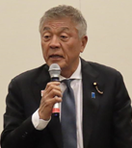
I am pleased that cricket will finally be adopted as an official Olympic sport at the 2028 Los Angeles Olympics. We also believe it will definitely be adopted in 2032 as well, as it will be held in Brisbane, Australia. India is also active in a variety of sports, but since it is a major cricket country, we feel that it will be very popular in India as well. I would like to ask you how this adoption for the Olympics is being received in the country and how sports are played in India, including for adults and children.

Constitutional Democratic Party, Ms. Motoko Mizuno, A member of the house of councilors
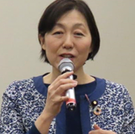
Ms. Mizuno said that she studied at JAXA (Japan Aerospace Exploration Agency) and visited India from time to time. And through NIAS (National Institute of Advanced Studies) and other organizations, she participated in research on space theory. Last summer, she visited India again to inspect the Delhi Metro, which was constructed with the support of JICA and Japan. She also visited Kolkata to study the long-term friendship between the two countries. At that time, she learned about India's vision and strategy in the digital domain. With my experience in dealing with India, she expressed her hope to promote more friendship and cooperation between Japan and India.

Independent, Mr. Kenichiro Saito, A member of the House of Councilors
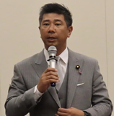
He understood that Japan's future relationship with India was important, but he felt that Japan and India must stand at the center of the new international order. In this perspective, he wanted to listen to Indian views and learn from them.

National Democratic Party, Mr. Satoshi Asano, A member of the House of Representatives
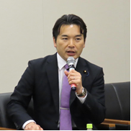
Since the theme for discussion was education, he wanted to ask just one question. Having a science background, he had the idea that Japan would like to increase the number of students in science fields in the future, and in particular, he wanted to focus on increasing the number of female students who are interested in science, but we are still in the middle of the road. He heard that many students in India are interested in the sciences. He wanted to the views of the speaker about the role of education in national building.

Komeito, Mr. Daisaku Hiraki, A member of the house of councilors
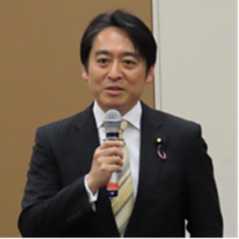
He recognized that the relationship between Japan and India would become increasingly important in the future. In particular, he was focusing on the need for UN reform. He believed that Japan and India have been working on UN reform for a number of years. Unfortunately, the UN has become dysfunctional, especially in the Security Council, and he thought that now was the time for Japan and India to work together to reform the UN. In particular, at this point in time, Japan and India have been working together within the framework of the G4, and the fact that India continued to maintain friendly relations with Russia was an important point when considering the future of the international community. He then asked Mr. Raji Kumar if he had any thoughts on future UN reform.

Constitutional Democratic Party, Ms. Ayaka Shiomura, A member of the House of Councilors
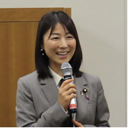
At a recent reception, the subject of UN reform came up. We also heard about Jindal University's rapid growth and the challenge of adding various faculties and other programs. Professors from distinguished Japanese universities such as the University of Tokyo, Osaka University, and Waseda University were also in attendance, and she thought they mentioned that they would like to collaborate with Jindal University to promote student exchange programs. She believed such cooperation between Japan and India would be particularly important for Japan's future. She had heard that cooperation between Japan and India is advancing in the field of international law, and he wanted to ask Jindal University if it had any ideas on UN reforms from its perspective.

Liberal Democratic Party, Mr. Hirobumi Niki, A member of the House of Representatives
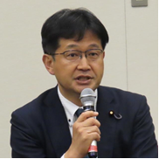
In Japan, after World War II, the Japanese developed by putting a lot of patience, energy, and money into education. He believed it was the same for India. Therefore, he wanted to ask Mr. Raj Kumar about the education system in India. For example, he heard that Indian children were able to calculate two-digit numbers by heart. He was surprised when he heard this. Also, can children from poor families attend private universities such as Jindal University? As a Japanese politician, he believed that education should be open to all citizens, as Japan is currently trying to reform its tuition fees and system. He wanted to hear what Raj Kumar thought about these ideas and his opinion in conjunction with the situation in India.
Komeito, Mr. Hideki Niizuma, A member of the House of Councilors
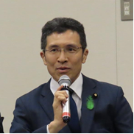
Since Suzuki Motor Corporation was mentioned earlier, he wanted to ask Mr. Kumar`s opinion on moving away from fossil fuels. I thought it important to reduce the use of fossil fuels, but at the same time, I recognize that fuels are also essential for development. I would like to ask you what you consider to be the ideal stage in the decarbonization of the automotive industry.

Liberal Democratic Party, Mr. Hiroyuki Kada, A member of the House of Councilors
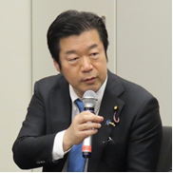
Mr. Kada informed that his constituency was Kobe City, and in 2019, Prime Minister Modi visited Kobe and established a partnership between Kobe City and Gujarat State and Kobe City and Ahmedabad. While economic and cultural exchanges have been taking place, he felt that cooperation among regions, municipalities, and towns would become more and more important in the future. In Kobe, the India Mela Kobe, the largest Indian event in western Japan, had been held 12 times. It has a long history, and about 20 Indian companies in Kobe are involved in exchanges with each other. The number of foreign tourists was also increasing. He believed that the promotion of grass-roots exchanges like this will become increasingly important in the future, and he looked forward to India`s continued support.

Liberal Democratic Party, Mr. Hisayuki Fujii, A member of the House of Representatives
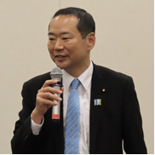
Mr. Hisayuki Fujii, Director of the Liberal Democratic Party's Foreign Affairs Department, joined the meeting introduced himself, and expressed his interest in strengthening the relations between Japan and India.

Session Three
Exchanges of Views among the Participants

Mr. Masakuni Tanimoto, Deputy Director of the Secretariat of the Japanese Parliamentary Committee for World Federalism
(He informed the participants that the meeting would now hold an exchange of views and opions and that it would be moderated by Mr. Sukehiro Hasegawa, former Special Representative of the Secretary-General of the United Nations, who was Chair of the Japan Advisory Commission on Global Governance, an expert advisory body to the National Diet of Japan.)

Sukehiro Hasegawa, Chairman of the Japan Advisory Commission on Global Governance
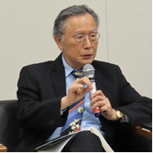
Mr. Hasegawa found that the remarks made by the members of the National Diet of Japan, including Minister of Education Moriyama, reflected the extent of the cooperative relationship that had already existed between Japan and India and the depth of mutual understanding between the Japanese and Indian communities.
He then pointed out three main issues the legislators raised: the international order and the rule of law, the importance of education and how to achieve it, and the prospect of economic and technical collaboration. Mr. Hasegawa then asked Mr. Raj Kumar to speak about these points.

O.P. Jindal Global University, Dr. Raj Kumar, Vice Chancellor
Thank you all for your time and for sharing your views. First, the rule of law and international order were extremely important. We should have faith in the functioning of the rule of law, and we should not hesitate to speak out when a case comes to the public that shakes the rule of law. Recognizing that the rule of law is being violated is the first step in constituting a society based on the rule of law. We believe that India and Japan should work closely together precisely to bring the rule of law into international politics. We also believe that India and Japan should work together to strengthen current international institutions. This is because, without strong international institutions to support the rule of law, we will be weak, and it will be impossible to maintain the rule of law. Finally, reform of the UN has also been one of the most important tasks in the history of the UN. In light of the current wars that are taking place around the world, we believe that UN reform is the most important issue at hand.

Sukehiro Hasegawa, Chairman of the Japan Advisory Commission on Global Governance
Japan and India want to become permanent members of the Council, as they are the more important members in Asia. Noting that China was against Japan and India becoming permanent members of the UN Security Council, he asked for Mr. Raj Kumar`s views.

O.P. Jindal Global University, Dr. Raj Kumar, Vice Chancellor
Of course, this is not acceptable. This must be done through negotiations and other means, and it is important to make the UN more democratic. This is to make it more inclusive and effective. The three things I have just mentioned - democratization, inclusiveness, and effectiveness - can only be achieved if both India and Japan become permanent members of the UN Security Council. Currently, the UN is failing to play an effective role despite the outbreak of war on a scale unparalleled in recent years. This is because the UN is slowly becoming weaker internally. So, we must work to make the UN strong and resilient. This is why we are reforming the UN structure. For example, the number of permanent members of the UN Security Council should be increased.

Then, in response to Mr. Sukehiro Hasegawa`s request, Professor Vesselin Popowski, an expert researcher on the United Nations, provided his views.

O.P Jindal Global University, Dr. Vesselin Popovski, Vice Dean of Law School
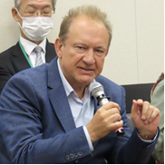
From the UN's perspective, inclusiveness and efficiency are important. However, a certain dilemma exists. If the Security Council were to be expanded too much, efficiency would be compromised. One point I would like to add is that eliminating the veto power of the permanent members of the Council is a top priority. Once the veto is removed, other reforms can be carried out smoothly and effectively. If the veto remains, even if we double the number of countries on the Security Council, China and Russia will continue to veto resolutions, and many people will continue to be killed as a result. The first step should be to eliminate the veto. Then, we should consider a Security Council structure that better represents each country, including making India and Japan permanent members of the Council.

Mr. Sukehiro Hasegawa, Chairman of the Japan Advisory Commission on Global Governance
Let me move on to the next question regarding education. Earlier, Mr. NIKI Hirobumi asked whether people from poor families can go to college.

O.P. Jindal Global University, Dr. Raj Kumar, Vice Chancellor
First, let me answer the cricket question that came up earlier. I have a deep personal connection with cricket. I have a personal connection to cricket because I used to be a cricketer. I am very excited that cricket has been selected for the Olympics. I believe sports play a very important role in building relations between nations. At the same time, it allows us to build a common consciousness of humanity. Therefore, I feel that sports play a significant role, and that is why I am very happy that a sport that is loved by 1.5 billion people in India and cricket, which is loved by so many people worldwide, has been included in the Olympics. I thank Mr. Kenta AOSHIMA for his efforts and contributions.

Let me continue to answer your question on education. One of the most important things India has done since independence in 1947 is to expand its educational system. This could not fulfill the hopes and potentials of a few. At that time, only the privileged, the wealthy, or the elite had access to higher education. In the 76 years since independence, the educational system has expanded tremendously, and the quality of education has improved at all levels, including primary and secondary education. Today, there are more than 1,100 universities and 50,000 colleges in India, providing opportunities for people to pursue higher education. The Indian higher education system currently enrolls more than 35 million students, the largest in the world and larger than that of China. All of this educational expansion has been based on five theories from the beginning. The first is the pursuit of excellence in all forms of education: science and technology, liberal arts, anthropology, social sciences, etc. This is the primary idea in the development of the educational system. Second, we believe that education is not something that strengthens only the economy. It strengthens, at the same time, strengthens society. Third is the availability and affordability. Education must be affordable in a democracy, and this has been brought about by the rapid progress of public educational institutions. These include public universities by state governments, national universities, IITs, IAMs, etc., all of which are supported by the state to make education accessible to all and inclusive of all. Recently, two new values in education have emerged. The creation of high-level research institutions and the creation of new knowledge through research. Creating high-standard research institutions has become one of the most important criteria in Indian education. Thus, research is encouraged by the state and by private universities and other institutions that are not public. Finally, effective investment. India is poorer than the U.S. and other Western countries and is inferior in terms of investment in science and technology. However, Indian scientists have been successful. For example, Indian scientists have successfully completed missions to Mars and the Moon. This is an accomplishment with a surprisingly small amount of investment compared to other countries. The investment per mission was less than the production cost of, for example, the Hollywood movies "Interstellar" and "Odyssey." Regarding education, finally, all public and private universities provide people with access to education. O.P. Jindal Global University is a private university, but more than 55% of our students are enrolled on some scholarship. The key is to keep tuition affordable so that access is possible regardless of each student's financial situation. This is because the founder, Mr. Naveen Jindal, invested a huge amount of money to reduce the cost of education.

Mr. Raj Kumar then commented on the issue of decarbonization which, he said, has been one of great importance in India in recent years. It is true that India still relies on coal for a large part of its energy industry. However, there is no doubt that in the last five years, the government's priorities and interests have shifted toward decarbonization. In addition, the contribution of the private sector has been significant. In particular, many companies, including Indian companies in the automotive industry, recognize the importance of decarbonization. The private sector is increasingly investing in developing vehicle technologies that do not rely on carbon emissions and is increasingly conscious of electric vehicles and those that are more combustion-efficient. In the most recent initiative, manufacturer JSW absorbed a long-established British car company called NG to promote EVs, which went on to hold a 33% share of the market. Thus, the transition to decarbonization by Indian automakers is still in its early stages, but it is moving at a fast pace.

As for why so many Indian students are interested in the sciences, the country is actually struggling to attract students to science and technology fields. In 2020, the Indian government announced an education policy that will require students to study in the science and technology fields to gain a better understanding of the science and technology fields in the country. The new policy provides for distinctions and preferences and is divided into science subjects and liberal education.

Mr. Sukehiro Hasegawa, Chairman of the Japan Advisory Commission on Global Governance
I would like to thank you, Mr. Raj Kumar, for your insightful information and explanation. You responded well to Chairman Seishiro ETO's request by indicating specifically the possibility of strengthening the relationship between Japan and India in the fields of education and diplomacy, including the United Nations. For our part, we feel that we would like to use your views and information as a valuable reference. Mr. Hasegawa then invited the representative from the Ministry of Foreign Affairs.

Ministry of Foreign Affairs, Mr. Makoto Hayashi, Deputy Director-General of Asian and Oceanian Affairs Bureau
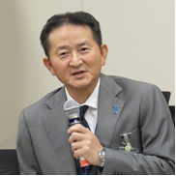
I would like to thank Vice President Raj Kumar for his speech today. I am also impressed by the World Federation of Japanese Parliamentary Committees' regular discussions on global governance. I have heard various valuable views on India's role in global governance. The Japanese government is also pursuing various foreign policy initiatives. It is pursuing diplomacy to maintain an international order based on the rule of law to realize a free and open Indo-Pacific region. With this in mind, Japan is strengthening its ties with the G7 and with its peers, such as Japan, the U.S., Australia, and India, and is also making efforts in the Global South. India is the key country in all of these efforts, and we will continue to strengthen our relationship with the Global South and India.

O.P. Jindal Global University, Dr. Raj Kumar, Vice Chancellor
I would like to leave a final comment. During my visit, I interacted with and formed partnerships with more than 10 universities in Tokyo, Kyoto, Osaka, Hiroshima, and other cities. These educational partnerships will help strengthen the relationship between Japan and India.

Liberal Democratic Party, Mr. Seishiro Eto, A member of the House of Representatives, The chairman of the Japanese Parliamentary Committee for World Federation
I would like to thank Mr. Raj Kumar, Vice Chancellor, and all of you for your extremely thought-provoking and valuable talks. I am reminded that India is an educational superpower. We are all looking forward to seeing the results of the elections in June in India, which has the largest population in the world.

Mr. Makuni Tanimoto then closed the meeting at about 5:30 p.m.

List of Participants

- Members of the National Diet of Japan who Attended in Person

[Liberal Democratic Party]
House of Representatives: Seishiro Eto, Kiyoshi Odawara, Hirobumi Niki, Hisayuki Hujii, Masahito Moriyama
House of Councilors: Hiroyuki Kada
[Constitutional Democratic Party]
House of Councilors: Ayaka Shiomura, Motoko Mizuno子
[Japan Innovation Party]
House of Representatives: Yoshiharu Asakawa
House of Councilors: Kenta Aoshima
[Komeito]
House of Councilors: Hideki Niizuma, Daisaku Hiraki
[National Democratic Party]
House of Representatives: Satoshi Asano
[Independent]
House of Councilors: Kenichiro Saitou

- Government
Ministry of Education, Culture, Sports, Science and Technology
Masahito Moriyama, Minister
Ministry of Foreign Affairs
Makoto Hayashi, Deputy Director-General of Asian and Oceanian Affairs Bureau

C. O.P. Jindal Global University
C. Raj Kumar, Founding Vice Chancellor
Kathleen Modrowski, Professor & Dean, Jindal School of Liberal Arts and Humanities
Mohan Kumar, Dean, Strategic & International Initiatives; Director, Jindal Global Centre for G20 Studies; Former Indian Ambassador to France and Bahrain
Vesselin Popovski, Professor & Vice Dean, Jindal Global Law School, Executive Director, Centre for the Study of United Nation
Padmanabha Ramanujam, Dean of Academic Governance and Student Life
Upasana Mahanta, Dean of Admissions and Outreach
Akhil Bhardwaj, Assistance Dean and Director, Office of International Affairs & Global Initiatives

- Host and Related Organizations
Seishiro Eto, Chairman of the Parliamentary Committee of the National Diet of Japan for World Federation
Sukehiro Hasegawa, Chairman of Japan Advisory Commission on Global Governance; Former Special Representative of the Secretary-General of the United Nations,

World Federalist Movement of Japan
Mitsuo Ohashi, Chairman
Osamu Shiohama, Board Member

The Secretariat of the Parliamentary Committee of the National Diet of Japan for World Federation
Osamu Shiohama, Director
Masakuni Tanimoto, Deputy Director
Keitoku Ikegami, Assistance to the Deputy Director
Student interns: Minaho Ishitsuka, Hein Na, Honoka Watanabe

